Certification Exam Registration Steps

- Login to Ciena Learning and search for your exam name and click enter. This example shows CEA-X in the search field, or search by “certification exam” to quickly find a list of all available exams.
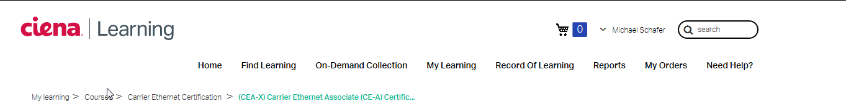

- The following window displays:
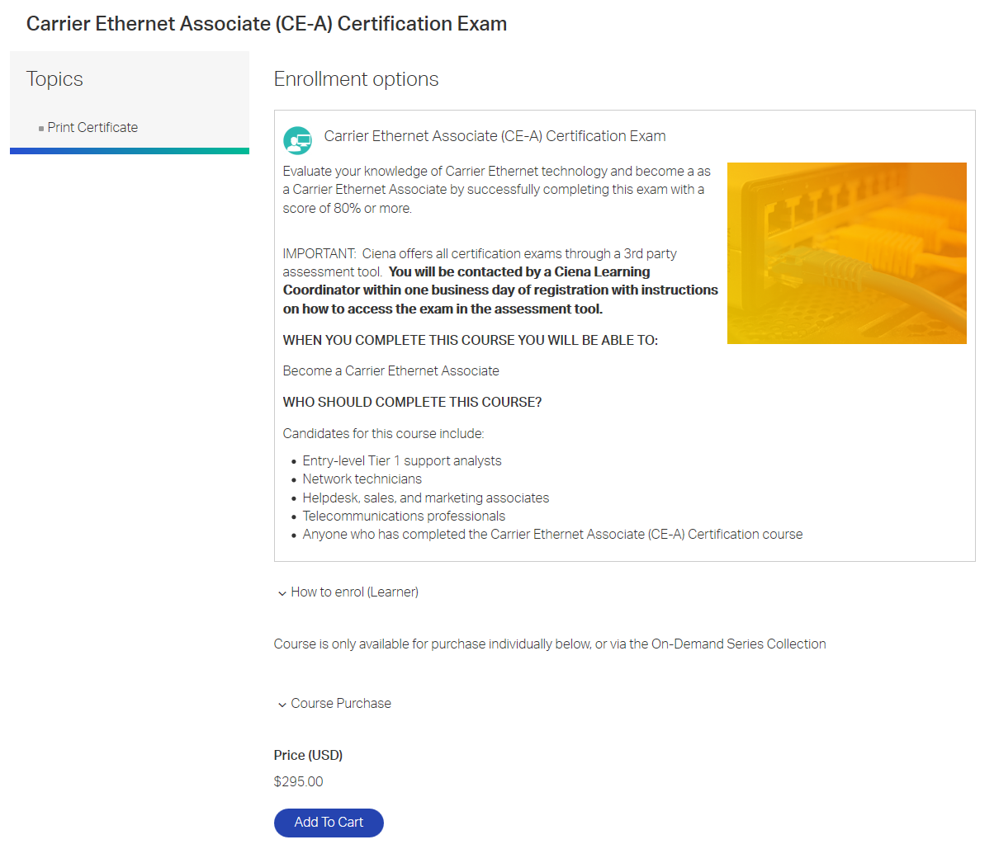
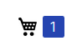
- Click the Add to Cart button to complete the registration.
The following message will appear above the Add to Cart as well as this icon at the top of the screen:

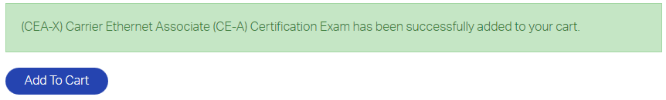

- Click on the shopping cart icon to proceed with the payment portion of the transaction.
The following will appear:

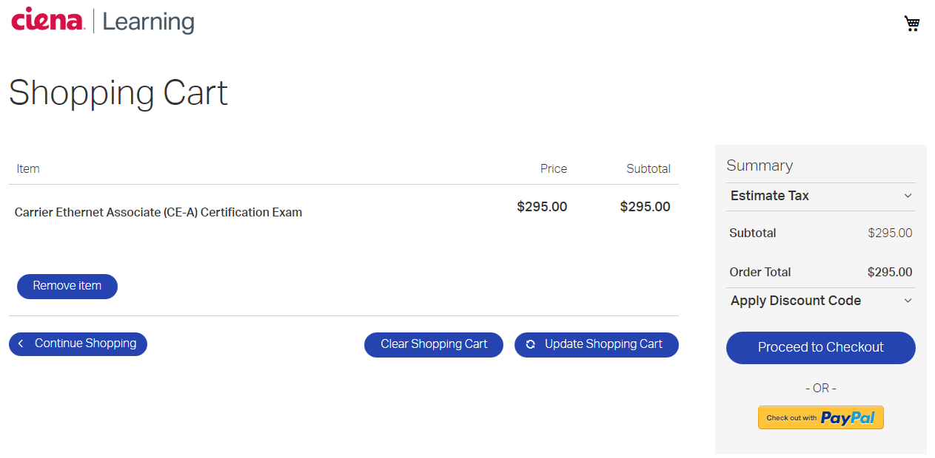

- Click the Proceed to Checkout button to select payment method.
The following will appear:
Select Training Credit.

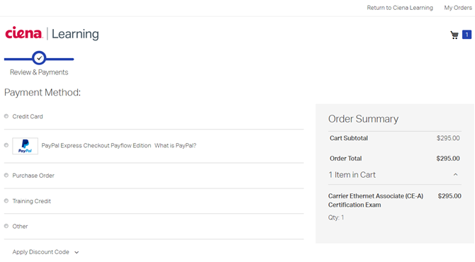

- Or select other method of payment on the left and, fill in the necessary information associated with the selected type of payment. If applicable the Apply Discount Code with the necessary information. Once all the info has been entered click the Place Order button on the bottom right of the page.

- Once the transaction is completed the following window will appear to let you know that you will be contacted by a Ciena Learning Coordinator within one business day with instructions on how to access the exam in the assessment tool. Please look for an email from learning@ciena.com with the instructions to access your exam:

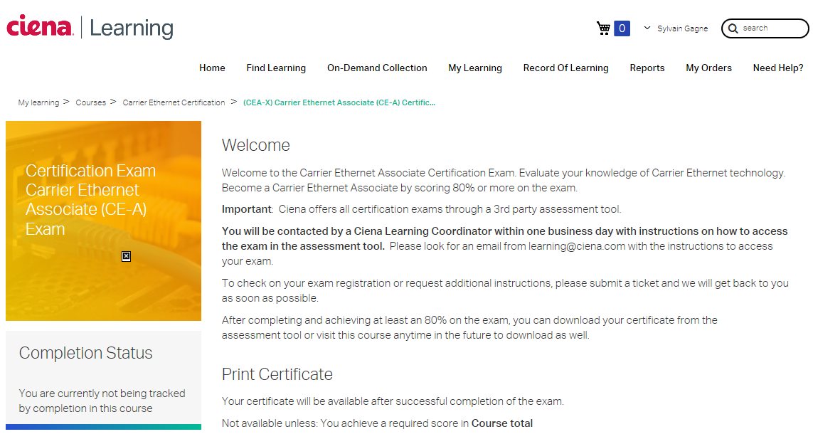

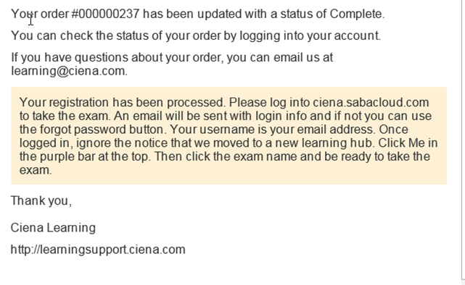

Please contact http://learningsupport.ciena.com if you run into one of the errors below:

